Pro

**Extro Brass Chrome-Plated Angle Cock with Lever Handle**

**Product Description:**

The Extro Brass Angle Cock features a premium chrome finish and sleek lever handle for smooth water control, making it an ideal addition for modern bathrooms and kitchens, ensuring durability and corrosion resistance.

**5 Key Features (Single Line):**

1. High-quality brass body with long-lasting chrome plating,
2. Elegant lever handle for effortless single-hand operation,
3. Rust-resistant and easy to clean glossy finish,
4. Wall flange included for secure and aesthetic mounting,
5. Ideal for bathroom and kitchen utility connections.

**Product Specifications:**

* **Brand:** Extro
* **Material:** Solid Brass
* **Finish:** Chrome-Plated
* **Color:** Silver
* **Mounting Type:** Wall Mounted
* **Handle Type:** Lever
* **Inlet Connection:** ½ inch BSP
* **Operation:** Quarter Turn
* **Application:** Angle Cock for Wash Basin, Kitchen, or Geyser Connection
* **Features:** Rust Resistant, Mirror Polish, Heavy-Duty Body

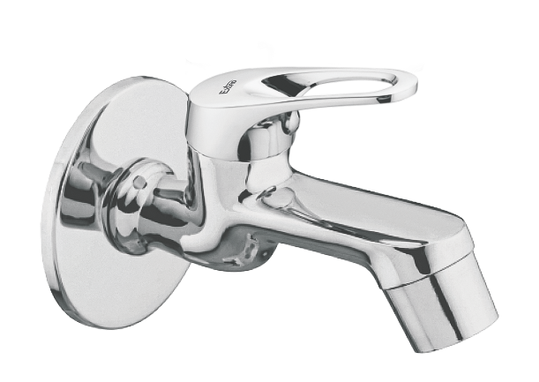

**Extro Brass Chrome-Plated Bib Cock with Lever Handle**

**Product Description:**

The Extro Bib Cock offers a sophisticated blend of utility and style with its corrosion-resistant chrome-plated brass body and ergonomic lever handle, ideal for modern bathrooms, wash areas, and utility setups.

**5 Key Features (Single Line):**

1. Premium chrome finish for long-lasting shine and corrosion resistance,
2. Single-lever handle ensures smooth and easy operation,
3. Made from high-quality brass for superior strength and durability,
4. Wall-mounted with sturdy flange support for hassle-free installation,
5. Compact design suitable for tight spaces and minimalist interiors.

**Product Specifications:**

* **Brand:** Extro
* **Material:** Solid Brass
* **Finish:** Chrome-Plated
* **Color:** Silver
* **Mounting Type:** Wall Mounted
* **Handle Type:** Lever
* **Inlet Connection:** ½ inch BSP
* **Operation:** Quarter Turn
* **Application:** Bib Cock for Wash Basin, Garden Tap, Utility Areas
* **Features:** Mirror Polish, Rust-Proof, Heavy-Duty Body, Sleek Handle Design

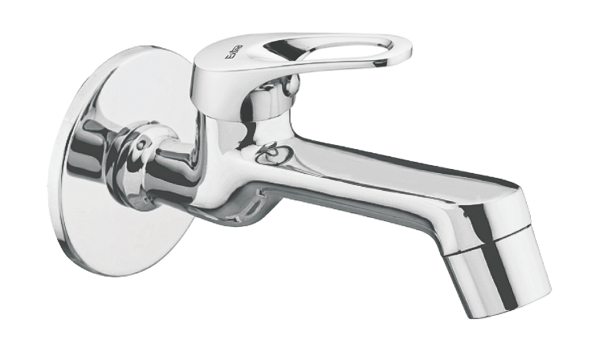

**Extro Brass Chrome-Plated Angular Stop Cock with Lever Handle**

**Product Description:**

The Extro Angular Stop Cock is a premium wall-mounted valve fixture, ideal for controlling water flow in bathroom or kitchen plumbing systems. Its sleek chrome-plated finish and ergonomic lever design make it both functional and aesthetically appealing.

**5 Key Features (Single Line):**

1. High-quality brass body ensures long-lasting durability,
2. Chrome-plated finish resists corrosion and tarnishing,
3. Ergonomic lever handle for smooth and easy water control,
4. Angular design saves space and supports directional water flow,
5. Integrated wall flange provides a clean and secure fit.

**Product Specifications:**

* **Brand:** Extro
* **Material:** Solid Brass
* **Finish:** Chrome-Plated
* **Color:** Silver
* **Mounting Type:** Wall Mounted
* **Handle Type:** Lever
* **Connection Size:** ½ inch BSP
* **Operation:** Quarter Turn
* **Usage:** Ideal for geysers, wash basins, flush tanks, kitchen sinks
* **Features:** Compact Design, Rust-Free, Leak-Proof, Mirror Polish

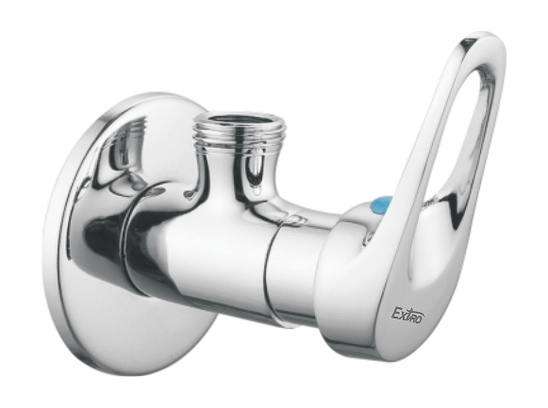

**Extro Concealed Brass Stop Valve with Lever Handle**

**Product Description:**

The Extro Concealed Brass Stop Valve is a premium, high-durability plumbing control valve designed for embedded wall installations. Ideal for bathrooms and kitchens, it offers precise water flow regulation with a sleek chrome-plated handle for a contemporary look.

**5 Key Features (Single Line):**

1. Solid brass body ensures superior strength and longevity,
2. Sleek chrome-finished lever handle for easy operation,
3. Concealed installation for a clean and elegant appearance,
4. Corrosion-resistant materials suitable for hot and cold water,
5. Leak-proof performance with smooth flow control.

**Product Specifications:**

* **Brand:** Extro
* **Material:** Brass (Body), Chrome-Plated Zinc/Alloy (Handle)
* **Finish:** Chrome
* **Color:** Silver and Brass
* **Mounting Type:** Concealed (Wall Installation)
* **Handle Type:** Single Lever
* **Connection Size:** 15mm (½ inch BSP Thread)
* **Operation:** Quarter Turn
* **Usage:** Bathrooms, Kitchens, Shower Panels
* **Features:** Rust-Free, High Pressure Resistant, Durable Internal Parts, Directional Flow Indicator

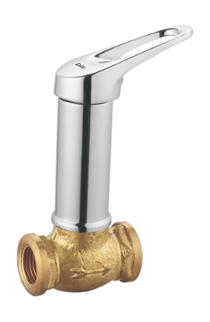

**Extro Table Mount Pillar Tap with Lever Handle**

**Product Description:**

The Extro Table Mount Pillar Tap offers a modern and efficient water dispensing solution, perfect for kitchen or washbasin setups. It features a smooth, ergonomic lever handle for easy operation, and a polished chrome finish that enhances the aesthetics of any space.

**5 Key Features (Single Line):**

1. Chrome-plated finish for a sleek and corrosion-resistant surface,
2. Easy-to-use single lever handle for precise flow control,
3. Durable brass body ensures long-term usage,
4. Modern, compact design suitable for table-top basins or sinks,
5. Easy installation with standard threaded connection.

**Product Specifications:**

* **Brand:** Extro
* **Material:** Brass (Body), Chrome Finish
* **Mount Type:** Table Mount (Deck Mount)
* **Color:** Silver
* **Finish:** Polished Chrome
* **Handle Type:** Single Lever
* **Spout Type:** Straight, Downward Facing
* **Installation Type:** 1-Hole
* **Thread Size:** 15mm BSP
* **Ideal Use:** Kitchen Sinks, Wash Basins
* **Features:** Leak-proof operation, Smooth turning mechanism, Anti-rust finish

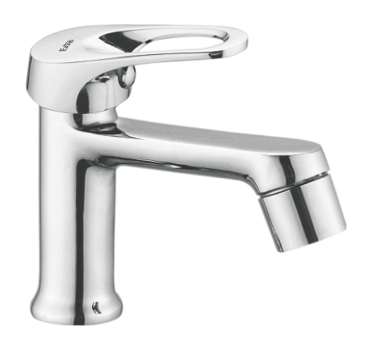

**Extro Wall Mixer with Overhead Shower Diverter**

**Product Description:**

The Extro Wall Mixer with Shower Diverter is a premium bath fitting designed for seamless switching between the spout and overhead shower. Built from high-grade brass with a polished chrome finish, it offers style, performance, and lasting durability for modern bathrooms.

**5 Key Features (Single Line):**

1. Dual-function operation for tap and shower output,
2. High-quality chrome finish for a sleek, rust-resistant look,
3. Smooth single-lever control for easy water mixing,
4. Durable brass construction for long-lasting use,
5. Wall-mounted design ideal for compact and elegant bathrooms.

**Product Specifications:**

* **Brand:** Extro
* **Material:** Brass
* **Finish:** Chrome Plated
* **Mount Type:** Wall Mounted
* **Color:** Silver
* **Handle Type:** Single Lever with Diverter
* **Functionality:** Tap and Overhead Shower Mixer
* **Inlet Connection:** Dual Inlet (Hot & Cold)
* **Outlet:** Spout + Shower Diverter
* **Thread Size:** Standard 15mm BSP
* **Features:** Corrosion-resistant, Easy flow control, Drip-free operation

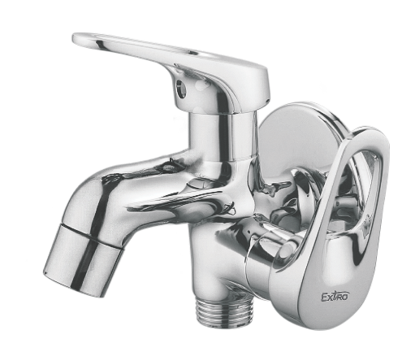

**Extro 2-Way Angle Valve with Single Lever**

**Product Description:**

The Extro 2-Way Angle Valve with Single Lever is a premium wall-mounted fitting designed for dual water control – ideal for geysers, washing machines, or bidet sprays. With its smooth operation and corrosion-resistant chrome finish, it combines style and functionality.

**5 Key Features (Single Line):**

1. Dual outlet design for multipurpose usage,
2. Premium chrome finish with corrosion resistance,
3. Smooth single lever operation for easy flow control,
4. Wall-mounted compact form for space-saving installation,
5. Brass body construction ensures long life and leak-proof performance.

**Product Specifications:**

* **Brand:** Extro
* **Material:** Brass
* **Finish:** Chrome Plated
* **Mount Type:** Wall Mounted
* **Color:** Silver
* **Function Type:** 2-Way Flow Control Valve
* **Handle Type:** Single Lever
* **Outlets:** Two (Main + Auxiliary for appliances or spray)
* **Inlet Size:** Standard 15mm BSP Thread
* **Applications:** Geysers, Washing Machines, Health Faucets
* **Features:** Rust-resistant, Easy installation, Durable body

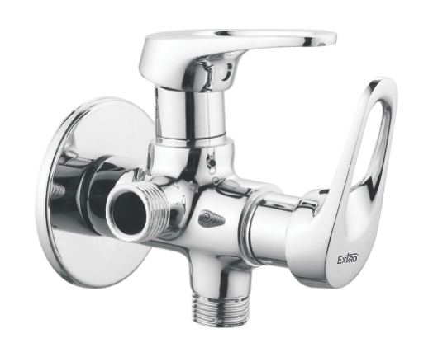

**Extro Sink Cock with Swivel Spout (Table Mounted)**

**Product Description:**

The Extro Table Mounted Sink Cock with Swivel Spout features a tall, elegant arc for optimum clearance and flexibility. Designed for modern kitchens and utility sinks, this faucet delivers a smooth, ergonomic operation with a stylish, chrome-plated finish that resists tarnishing.

**5 Key Features (Single Line):**

1. 360° swivel spout for wide reach and sink coverage,
2. Single lever handle for easy one-touch operation,
3. Chrome finish resists corrosion and tarnish,
4. High-arc design enhances usability and cleaning space,
5. Brass body ensures long-term durability and leak resistance.

**Product Specifications:**

* **Brand:** Extro
* **Model:** Sink Cock with Swivel Spout (Table Mounted)
* **Material:** Brass
* **Finish:** Chrome Plated
* **Mount Type:** Table Mounted
* **Spout Type:** Swivel Spout, 360° Rotation
* **Handle Type:** Single Lever
* **Inlet Connection Size:** 15mm BSP Thread
* **Height:** Tall spout for ample sink clearance
* **Application:** Kitchen Sink, Utility Basin
* **Features:** Rust-resistant, Smooth flow, Easy installation

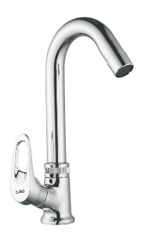

**Extro Wall Mounted Sink Cock with Swivel Spout**

**Product Description:**

The Extro Wall Mounted Sink Cock with Swivel Spout combines functionality and aesthetics, featuring a high-arc swivel design ideal for kitchen and utility sinks. This space-saving fixture ensures easy wall installation and delivers a smooth, consistent water flow with user-friendly control.

**5 Key Features (Single Line):**

1. 360° rotating spout ensures flexible sink access,
2. Wall-mounted design saves counter space,
3. Sleek single-lever handle for precise water control,
4. Premium chrome plating resists rust and tarnish,
5. Brass construction for long-lasting durability.

**Product Specifications:**

* **Brand:** Extro
* **Model:** Wall Mounted Sink Cock with Swivel Spout
* **Material:** Brass
* **Finish:** Chrome Plated
* **Mount Type:** Wall Mounted
* **Spout Type:** Swivel Spout, 360° Rotation
* **Handle Type:** Single Lever
* **Inlet Connection Size:** 15mm BSP
* **Suitable For:** Kitchen Sinks, Utility Basins
* **Flow Type:** Regular Flow
* **Features:** Corrosion-resistant, Easy to install, Ergonomic design

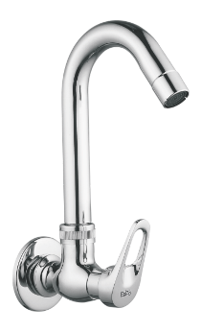

**Extro Table Mounted Swan Neck Sink Mixer**

**Product Description:**

The Extro Table Mounted Swan Neck Sink Mixer is a dual-handle faucet designed for modern kitchens, featuring a high-arc swan neck spout for extended reach and ease of use. With separate controls for hot and cold water, it ensures precision and comfort for everyday use.

**5 Key Features (Single Line):**

1. Elegant swan neck spout with 360° swivel,
2. Dual-lever design for hot and cold water control,
3. Solid brass body with durable chrome finish,
4. Smooth quarter-turn ceramic disc operation,
5. Splash-free aerator for gentle and efficient water flow.

**Product Specifications:**

* **Brand:** Extro
* **Model:** Table Mounted Swan Neck Sink Mixer
* **Material:** Brass
* **Finish:** Chrome Plated
* **Mount Type:** Table Mounted
* **Spout Type:** Swan Neck, Swivel Spout
* **Handle Type:** Dual Lever (Hot & Cold)
* **Inlet Connection Size:** 15mm BSP
* **Flow Type:** Regular, with Aerator
* **Applications:** Kitchen sinks, Utility areas
* **Features:** Corrosion-resistant, Long life cartridge, Ergonomic design

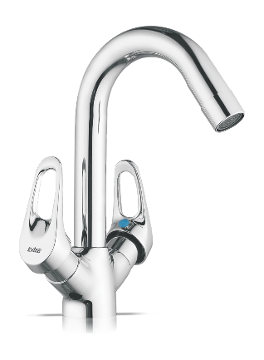

**Extro Dual Lever Wall Mounted Swan Neck Sink Mixer**

**📝 Product Description:**  
This wall-mounted dual lever sink mixer from Extro features a graceful swan neck spout and ergonomic design, perfect for stylish and efficient kitchen or utility applications where space and performance matter.

**✨ 5 Key Features (Single Line Each):**

1. Dual lever control for separate hot and cold water mixing
2. Swan neck spout for extended reach and ease of washing
3. Wall-mounted design saves counter space and ensures neat installation
4. Durable brass construction with mirror chrome finish
5. Drip-free ceramic cartridge for smooth and long-lasting operation

**📐 Product Specifications:**

* **Material:** Brass body with chrome finish
* **Installation Type:** Wall mounted
* **Handle Type:** Dual lever
* **Spout Type:** Swan neck
* **Finish:** Polished chrome
* **Cartridge:** Ceramic disc
* **Inlet Connection Size:** Standard 15mm BSP
* **Application:** Ideal for kitchens, pantries, and utility wash areas

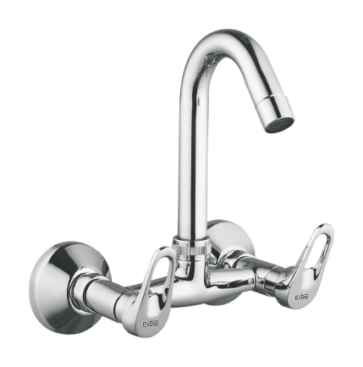

**Extro Wall Mixer with L Bend and Provision for Overhead Shower**

**📝 Product Description:**  
This Extro wall mixer is a premium bathroom fixture designed with dual lever control, an integrated L-bend pipe for overhead shower connection, and a front-flow outlet. Perfect for bath and shower systems, it delivers style, reliability, and versatility.

**✨ 5 Key Features (Single Line Each):**

1. Dual lever system allows precise mixing of hot and cold water
2. Built-in provision for overhead shower with sturdy L-bend connection
3. Durable brass body with polished chrome finish for long-term use
4. Wall-mounted installation ensures clean, space-saving aesthetics
5. Drip-free ceramic disc technology ensures smooth operation and water savings

**📐 Product Specifications:**

* **Material:** Brass with chrome finish
* **Installation Type:** Wall mounted
* **Handle Type:** Dual lever
* **Outlet Options:** Front spout and overhead shower provision
* **Spout Type:** Regular wall mixer with L-bend pipe
* **Finish:** High-gloss chrome
* **Cartridge Type:** Ceramic disc
* **Inlet Connection:** 15mm BSP standard
* **Application:** Suitable for bathrooms with combined bath and shower setups

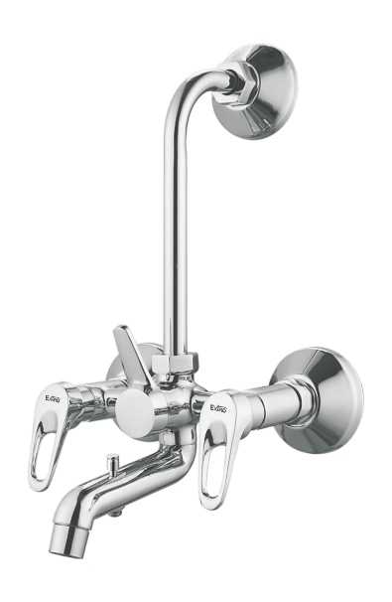

**Extro Wall Mixer with Crutch for Overhead and Hand Shower (with L Bend)**

**📝 Product Description:**  
This Extro wall mixer is a sophisticated bathroom fixture featuring dual lever control, a center diverter knob, an L-bend pipe for overhead shower, and an additional provision for a hand shower. Ideal for luxurious bathing setups combining versatility, comfort, and performance.

**✨ 5 Key Features (Single Line Each):**

1. Dual lever handles offer precise hot and cold water mixing
2. Diverter control lets you switch between spout, overhead, and hand shower
3. Integrated L-bend pipe for overhead shower connection
4. Stylish and durable chrome-plated brass construction
5. Easy wall-mounted installation with universal compatibility

**📐 Product Specifications:**

* **Material:** Brass with chrome plating
* **Mounting Type:** Wall-mounted
* **Handle Type:** Dual lever
* **Outlets:** Front spout, overhead shower, and hand shower option
* **Diverter Mechanism:** Knob type central diverter
* **Finish:** Mirror-like polished chrome
* **Cartridge:** Ceramic disc for smooth operation
* **Connection Type:** Standard 15mm BSP
* **Ideal For:** Bathroom setups with dual showering options (overhead + hand)

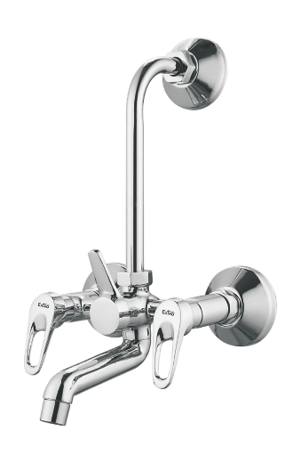

**Extro Table Mount Sink Cock with Swivel Spout**

**📝 Product Description:**  
The Extro Table Mount Sink Cock is a premium kitchen faucet designed with a sleek, ergonomic lever and a high arc swivel spout for full sink coverage. Its contemporary design and durable brass body with chrome finish make it ideal for modular kitchens and countertop basins.

**✨ 5 Key Features (Single Line Each):**

1. High-arc swivel spout for greater sink accessibility
2. Smooth single-lever control for water flow and temperature
3. Chrome-plated brass body ensures durability and rust resistance
4. Modern design enhances kitchen aesthetics
5. Easy table-top installation with universal fitment

**📐 Product Specifications:**

* **Material:** Brass with chrome finish
* **Mounting Type:** Table mounted (deck mount)
* **Handle Type:** Single lever
* **Spout Type:** 360° swivel spout (Gooseneck)
* **Finish:** Mirror polish chrome
* **Cartridge Type:** Ceramic disc cartridge
* **Inlet Connection:** Standard 15mm BSP
* **Usage:** Suitable for kitchen sinks or wash basins

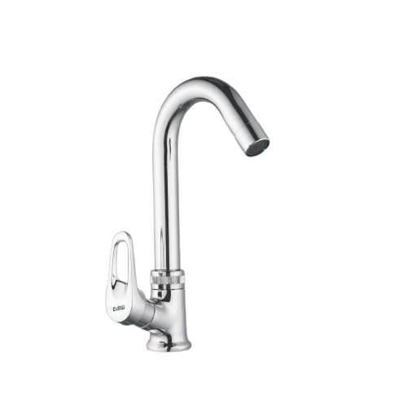

**Extro Table Mount Swan Neck Tap – Dual Handle**

**📝 Product Description:**  
The Extro Table Mount Swan Neck Tap with dual lever handles is designed to offer elegant functionality with precise temperature and flow control. Ideal for modern kitchens and wash basins, it combines practicality with a premium aesthetic.

**✨ 5 Key Features (Single Line Each):**

1. Dual lever control for independent hot and cold water regulation
2. High-rise swan neck spout ensures easy washing and filling
3. Brass body with corrosion-resistant chrome finish
4. Smooth ceramic cartridge operation for drip-free performance
5. Easy deck-mount installation with universal fit

**📐 Product Specifications:**

* **Material:** Brass with chrome plating
* **Mounting Type:** Table mount / deck mount
* **Handle Type:** Dual lever handles
* **Spout Type:** High-rise swan neck
* **Finish:** Glossy chrome
* **Cartridge:** High-quality ceramic disc cartridge
* **Inlet Size:** 15mm BSP (standard connection)
* **Application:** Suitable for kitchen sinks, utility counters, and basin areas

